B.TECH. (2020-24)
Artificial Intelligence

Lab File
on
Digital Electronics and Computer Organization
[CSE207]

Submitted To
Ms Neha Arora

Submitted By
Hitesh
A023119820027
4CSE11 (AI)

DEPARTMENT OF COMPUTER SCIENCE AND ENGINEERING
AMITY SCHOOL OF ENGINEERING AND TECHNOLOGY
AMITY UNIVERSITY UTTAR PRADESH
NOIDA (U.P)

INDEX

S.No | Category of Assignment | Code | Exp.  No. | Name of Experiment | Date of Allotment  of experiment | Date  of Evaluation | Max.  Marks | Marks obtained | Signature of Faculty
1. | Mandatory Experiment* | LR (10) | 1
2. | Mandatory Experiment* | LR (10) | 2
3. | Mandatory Experiment* | LR (10) | 3
4. | Mandatory Experiment* | LR (10) | 4
5. | Mandatory Experiment* | LR (10) | 5
6. | Mandatory Experiment* | LR (10) | 6
7 | Mandatory Experiment* | LR (10) | 7
8. | Mandatory Experiment* | LR (10) | 8
9. | Mandatory Experiment* | LR (10) | 9
10. | Mandatory Experiment* | LR (10) | 10
11. | Design Based Open Ended experiment** | PR (10)
12. | Viva | Viva (5)

Experiment – 1

AIM
To verify and interpret the logic and truth table for AND, OR, NOT, NAND, NOR, Ex-OR, Ex-NOR gates.

PLATFORM/TOOL USED
- Simulator: https://circuitverse.org/simulator
- Virtual LAB: https://de-iitr.vlabs.ac.in/exp/realization-of-logic-functions/

THEORY
Logic gates are electronic circuits which perform logical functions on one or more inputs to produce one output.
AIM: To verify and interpret the logic and truth table for
AND, OR, NOT, NAND, NOR, Ex-OR, Ex-NOR gates using RTL
(Resistor Transistor Logic), DTL (Diode Transistor Logic) and
TTL (Transistor Transistor Logic) logics.
THEORY: Logic gates are the basic building blocks of any
digital system. Logic gates are electronic circuits having one
or more than one input and only one output. The relationship
between the input and the output is based on a certain logic.
Based on this, logic gates are named as
1) AND gate
2) OR gate
3) NOT gate
4) NAND gate
5) NOR gate
6) Ex-OR gate
7) Ex-NOR gate
AIM: To verify and interpret the logic and truth table for
AND, OR, NOT, NAND, NOR, Ex-OR, Ex-NOR gates using RTL
(Resistor Transistor Logic), DTL (Diode Transistor Logic) and
TTL (Transistor Transistor Logic) logics.
THEORY: Logic gates are the basic building blocks of any
digital system. Logic gates are electronic circuits having one
or more than one input and only one output. The relationship
between the input and the output is based on a certain logic.
Based on this, logic gates are named as
1) AND gate
2) OR gate
3) NOT gate
4) NAND gate
5) NOR gate
6) Ex-OR gate
7) Ex-NOR gate
They are the basic building blocks of any digital system. Logic gates are electronic circuits having one or more than one input and only one output. The relationship between the input and the output is based on a certain logic. Based on this, there are seven logic gates –
- AND gate
- OR gate
- NOT gate
- NAND gate
- NOR gate
- Ex-OR gate
- Ex-NOR gate
When all the input combinations of a logic gate are written in a series and their corresponding outputs written along them, then this input/ output combination is called Truth Table.
The Karnaugh Map (K-Map) method is a systematic way of simplifying Boolean expressions. With the help of the K-map method, we can find the simplest POS and SOP expression, which is known as the minimum expression. The K-map provides a cookbook for simplification.
Just like the truth table, a K-map contains all the possible values of input variables and their corresponding output values. However, in K-map, the values are stored in cells of the array. In each cell, a binary value of each input variable is stored.

- AND Gate
- The AND gate is an electronic circuit that gives a high output (1) only if all its inputs are high. A dot (.) is used to show the AND operation i.e. A.B or can be written as AB.
- The IC number of AND Gate is 7408.

Truth Table of AND Gate
INPUT |  | OUTPUT
A | B | Y = A.B
0 | 0 | 0
0 | 1 | 0
1 | 0 | 0
1 | 1 | 1

K- Map of AND Gate
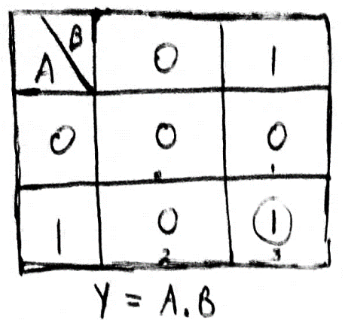

Boolean Expression of AND Gate
Y = A.B

Logic Symbol of AND Gate
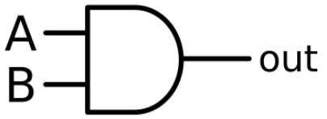
- OR Gate
- The OR gate is an electronic circuit that gives a high output (1) if one or more of its inputs are high. A plus (+) is used to show the OR operation.
- The IC number of OR Gate is 7432.
Truth Table of OR Gate
INPUT |  | OUTPUT
A | B | Y = A+B
0 | 0 | 0
0 | 1 | 1
1 | 0 | 1
1 | 1 | 1

K- Map of OR Gate
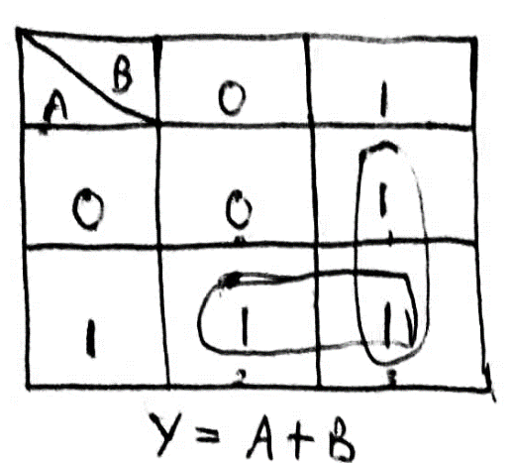

Boolean Expression of OR Gate
Y = A+B

Logic Symbol of OR Gate
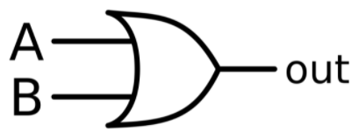
- NOT Gate
- The NOT gate is an electronic circuit that produces an inverted version of the input at its output. It is also known as an inverter. If the input variable is A, the inverted output is known as NOT A.
- The IC number of NOT Gate is 7404.
Truth Table of NOT Gate
INPUT | OUTPUT
A | Y = $\overline{A}$
0 | 1
1 | 0

Boolean Expression of NOT Gate
Y = $\overline{A}$

Logic Symbol of NOT Gate
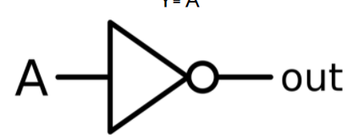
- NAND Gate
- This is a NOT-AND gate which is equal to an AND gate followed by a NOT gate. The outputs of all NAND gates are high if any of the inputs are low. The symbol is an AND gate with a small circle on the output. The small circle represents inversion.
- The IC number of NAND Gate is 7400.
Truth Table of NAND Gate
INPUT |  | OUTPUT
A | B | Y = $\overline{AB}$
0 | 0 | 1
0 | 1 | 1
1 | 0 | 1
1 | 1 | 0

K- Map of NAND Gate
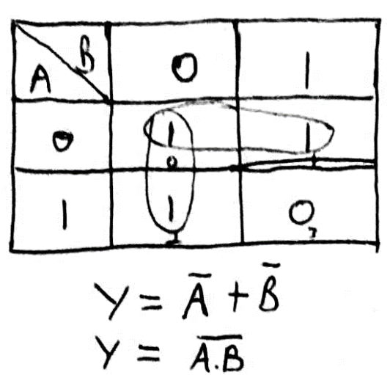

Boolean Expression of NAND Gate
Y = $\overline{AB}$

Logic Symbol of NAND Gate
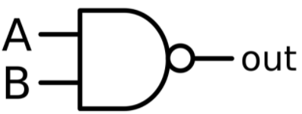
- NOR Gate
- This is a NOT-OR gate which is equal to an OR gate followed by a NOT gate. The outputs of all NOR gates are low if any of the inputs are high. The symbol is an OR gate with a small circle on the output. The small circle represents inversion.
- The IC number of NOR Gate is 7402.

Truth Table of NOR Gate
INPUT |  | OUTPUT
A | B | Y = $\overline{A+B}$
0 | 0 | 1
0 | 1 | 0
1 | 0 | 0
1 | 1 | 0

K- Map of NOR Gate
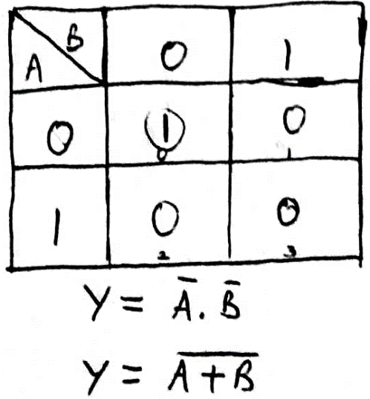

Boolean Expression of NOR Gate
Y = $\overline{A+B}$

Logic Symbol of NOR Gate
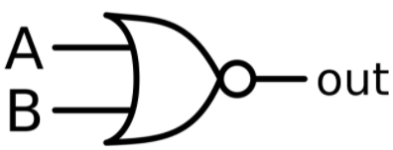
- Ex-OR Gate
- The 'Exclusive-OR' gate is a circuit which will give a high output if either, but not both of its two inputs are high. An encircled plus sign (⊕) is used to show the Ex-OR operation.
- The IC number of X-OR Gate is 7486.

Truth Table of XOR Gate
INPUT |  | OUTPUT
A | B | Y= A⊕B
0 | 0 | 0
0 | 1 | 1
1 | 0 | 1
1 | 1 | 0

K- Map of XOR Gate
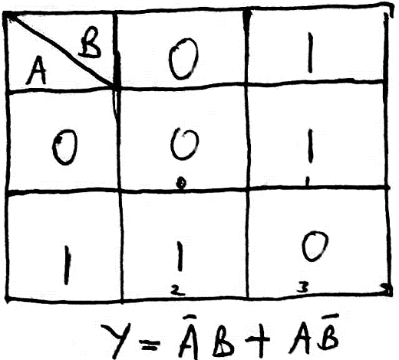

Boolean Expression of XOR Gate
Y= A⊕B

Y = $\overline{A}$B + A$\overline{B}$

Logic Symbol of XOR Gate
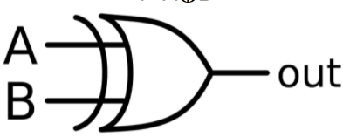
- Ex-NOR Gate
- The 'Exclusive-NOR' gate circuit does the opposite to the EX-OR gate. It will give a low output if either, but not both of its two inputs are high. The symbol is an EX-OR gate with a small circle on the output. The small circle represents inversion.
- The IC number of Ex-NOR Gate as CMOS IC is the 4077, and the TTL IC is the 74266.

Truth Table of XOR Gate
INPUT |  | OUTPUT
A | B | Y= $\overline{A⊕B}$
0 | 0 | 1
0 | 1 | 0
1 | 0 | 0
1 | 1 | 1

K- Map of XOR Gate
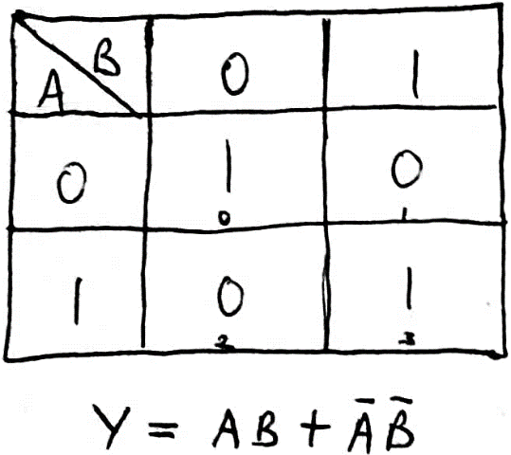

Boolean Expression of XOR Gate
Y= $\overline{A⊕B}$
Y = AB + $\overline{A}\overline{B}$

Logic Symbol of XOR Gate
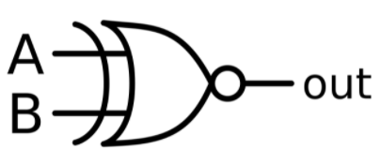

SIMULATED OUTPUT
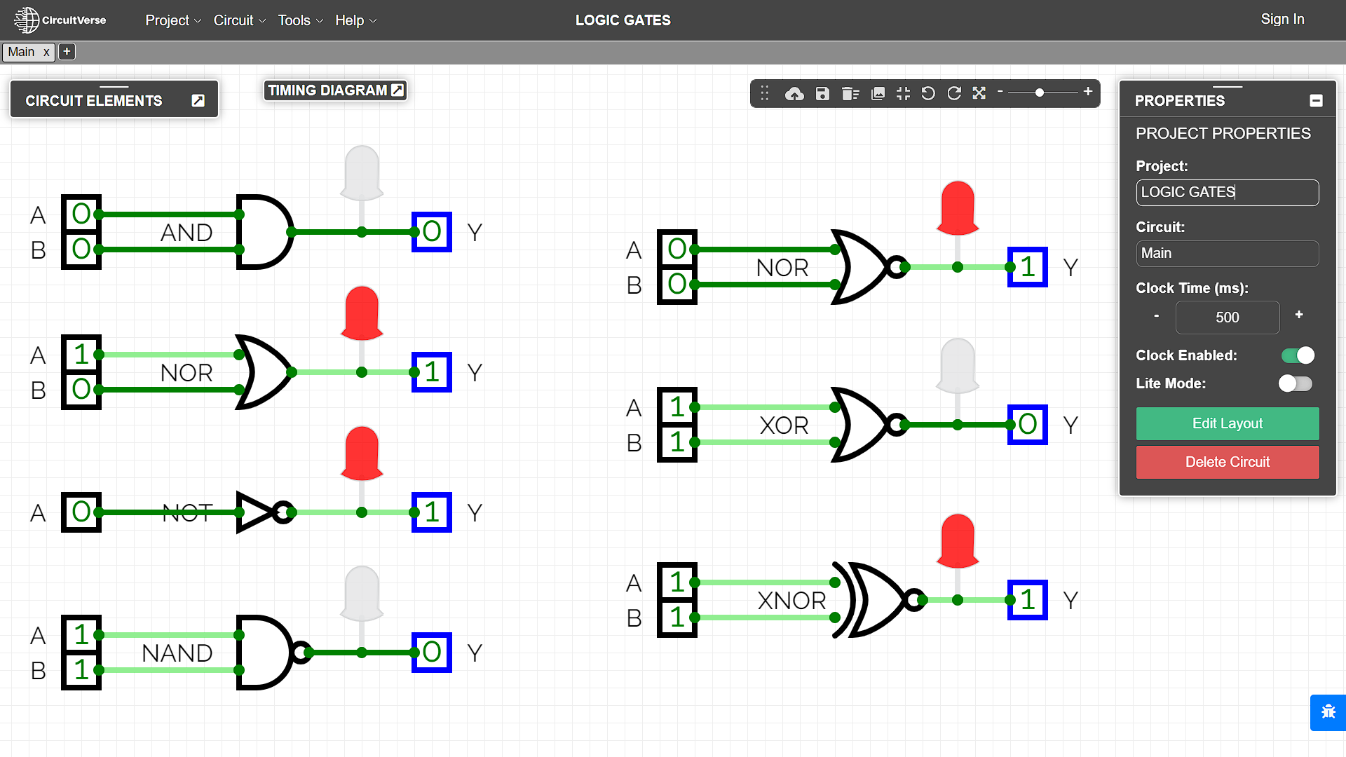

RESULT
The Boolean Expressions and Truth Tables of Logic and Universal gates have been studied and verified using the online simulator.

Criteria | Total Marks | Marks Obtained | Comments
Concept (A) | 2
Implementation (B) | 2
Performance (C) | 2
Total | 6

Experiment – 2

AIM
To study and design the single bit half adder and full adder combinational circuits by using (1) XOR and (2) NAND gates respectively to verify and interpret their logic and truth tables and analyse the working of half adder and full adder circuit.
PLATFORM/TOOL USED
- Simulator: https://circuitverse.org/simulator
- Virtual LAB: https://de-iitr.vlabs.ac.in/exp/half-full-adder/
THEORY
An Adder is a digital logic circuit in electronics that is extensively used for the addition of numbers. In many computers and other types of processors, adders are even used to calculate addresses and related activities and calculate table indices in the ALU and even utilized in other parts of the processors.
Adders are a key component of arithmetic logic unit. Adders can be constructed for most of the numerical representations like Binary Coded Decimal (BCD), Excess – 3, Gray code, Binary etc. out of these, binary addition is the most frequently performed task by most common adders. Apart from addition, adders are also used in certain digital applications like table index calculation, address decoding etc.

Binary addition is like that of decimal addition. Some basic binary additions are shown below.
0 0 1 1
+0 +1 +0 +1
0 1 1 (carry) 1 0

Adders are basically classified into two types: Half Adder and Full Adder.

- Half Adder
- Half adder is a combinational circuit that performs simple addition of two binary bits.
- It has 2 inputs that represent the 2 bits to be added and 2 outputs, with one producing the SUM output and the other producing the CARRY.
- If we assume A and B as the two bits whose addition is to be performed, the block diagram and a truth table for half adder with A, B as inputs and Sum, Carry as outputs can be tabulated as follows:

Block Diagram for HALF ADDER
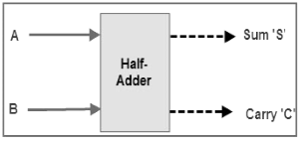

Truth Table for HALF ADDER
INPUT |  | OUTPUT
A | B | Carry (C) | Sum (S)
0 | 0 | 0 | 0
0 | 1 | 0 | 1
1 | 0 | 0 | 1
1 | 1 | 1 | 0

K-Map for HALF ADDER
For SUM For CARRY
B  A | 0 | 1 |  |  | B  A | 0 | 1
0 | 0 | 1 |  |  | 0 | 0 | 0
1 | 1 | 0 |  |  | 1 | 0 | 1
$$Sum = AB^{'}+ A^{'}B$$  $$Sum=A⊕B$$ |  |  |  |  | $$Carry = AB$$

Boolean Expression for HALF ADDER
$\boxed{Sum = AB^{'}+ A^{'}B=A⊕B}$ $\boxed{Carry = AB}$

Logic Diagram for HALF ADDER
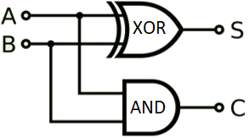

- Five NAND gates are required to design a half adder.

Realization of Half Adder using 5 NAND gates
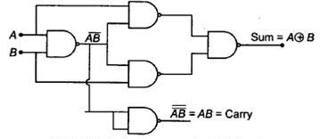
- Full Adder
- Full adder is a digital combinational circuit used to calculate the sum of three binary bits. Full adders are complex and difficult to implement when compared to half adders.
- It consists of 3 inputs and 2 outputs.
- The full adder overcomes the limitation of the half adder, which can be used to add two bits only.
- Two of the three bits are same as before which are A, the augend bit and B, the addend bit. The additional third bit is carry bit from the previous stage and is called 'Carry-in' generally represented by C_{IN}. It calculates the sum of three bits along with the carry. The output carry is called 'Carry-out' and is represented by C_{OUT}.
- As there 3 input variables, 8 different output combinations are possible.
- The block diagram and truth table of a full adder with A, B and C_{IN} as inputs and S, Carry OUT as outputs can be tabulated as follows:
Block Diagram for FULL ADDER
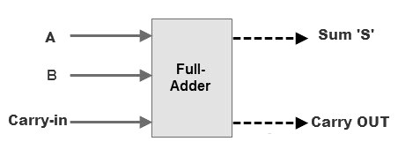
Truth Table for FULL ADDER
INPUT |  |  | OUTPUT
A | B | C_{IN} | SUM | C_{OUT}
0 | 0 | 0 | 0 | 0
0 | 0 | 1 | 1 | 0
0 | 1 | 0 | 1 | 0
0 | 1 | 1 | 0 | 1
1 | 0 | 0 | 1 | 0
1 | 0 | 1 | 0 | 1
1 | 1 | 0 | 0 | 1
1 | 1 | 1 | 1 | 1

K-Map for FULL ADDER
For SUM |  |  |  |  |  | For Carry_{out}
BC_{IN}  A | 00 | 01 | 11 | 10 |  | BC_{IN}  A | 00 | 01 | 11 | 10
0 | 0 | 1 | 0 | 1 |  | 0 | 0 | 0 | 1 | 0
1 | 1 | 0 | 1 | 0 |  | 1 | 0 | 1 | 1 | 1
$$Sum =A^{'}B^{'}C_{in}+A^{'}BC_{in}^{'}+{AB}^{'}C_{in}^{'}+ABC_{in}$$  $$Sum=A⊕B ⊕C_{IN}$$ |  |  |  |  |  | $$C_{out} = AB+AC_{in}+AC_{in}$$  $$C_{out}=AB+C_{in}(A⊕B)$$

Boolean Expression for HALF ADDER
$$\boxed{Sum =A^{'}B^{'}C_{in}+A^{'}BC_{in}^{'}+{AB}^{'}C_{in}^{'}+ABC_{in}=A⊕B ⊕C_{IN}}$$
$$\boxed{C_{out} = AB+AC_{in}+AC_{in}=AB+C_{in}(A⊕B)}$$

Logic Diagram for FULL ADDER
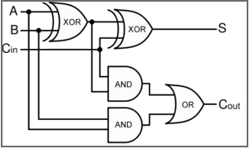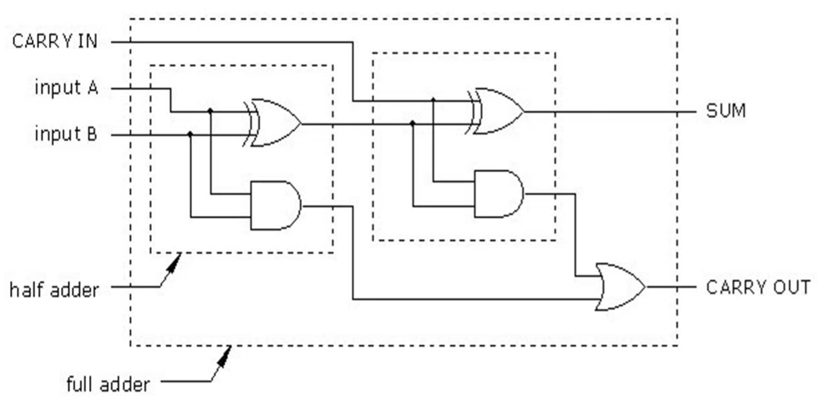

- Nine NAND gates are required to design a full adder.

Realization of FULL Adder using 9 NAND gates
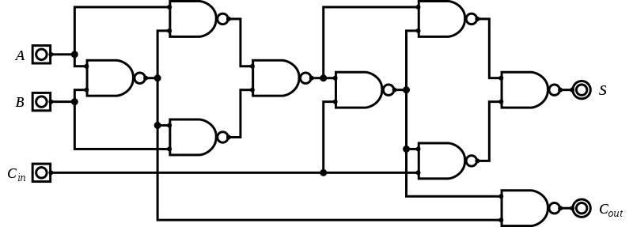
SIMULATED OUTPUT

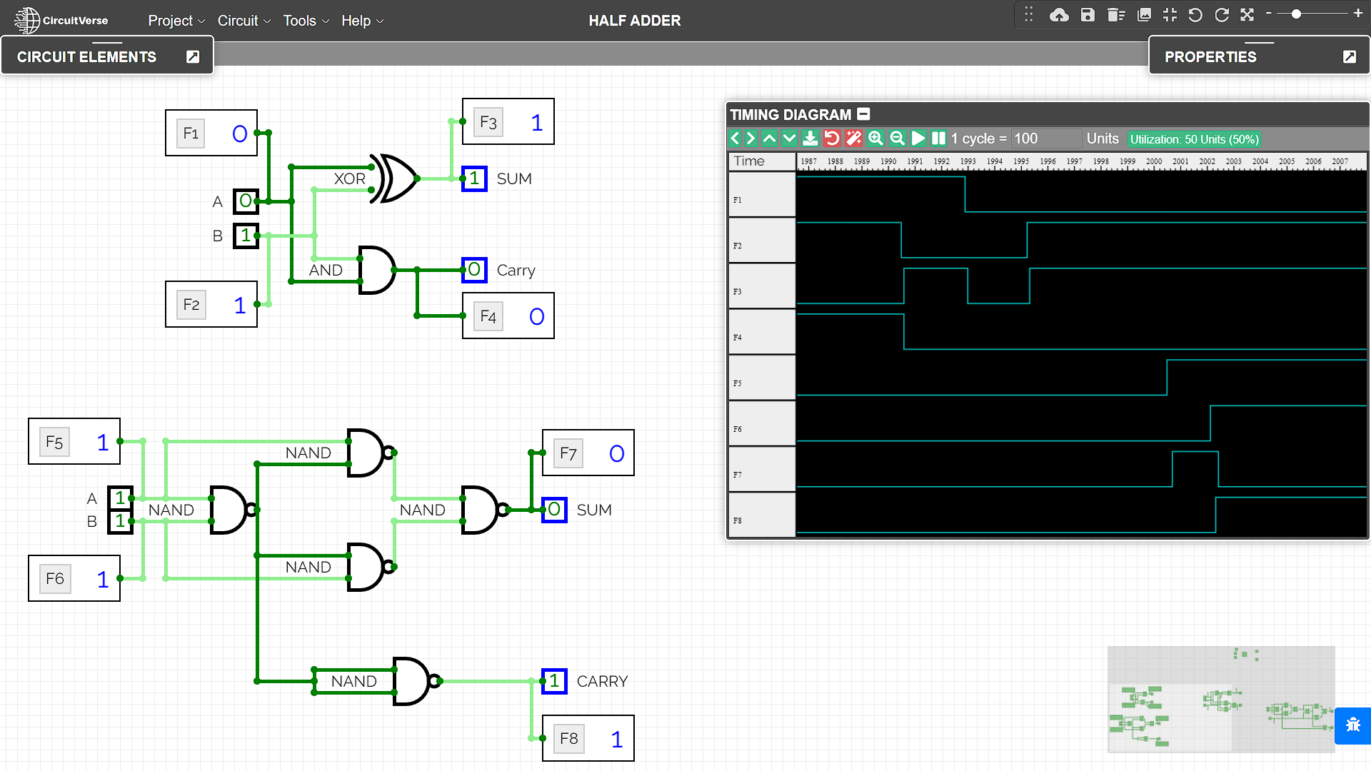

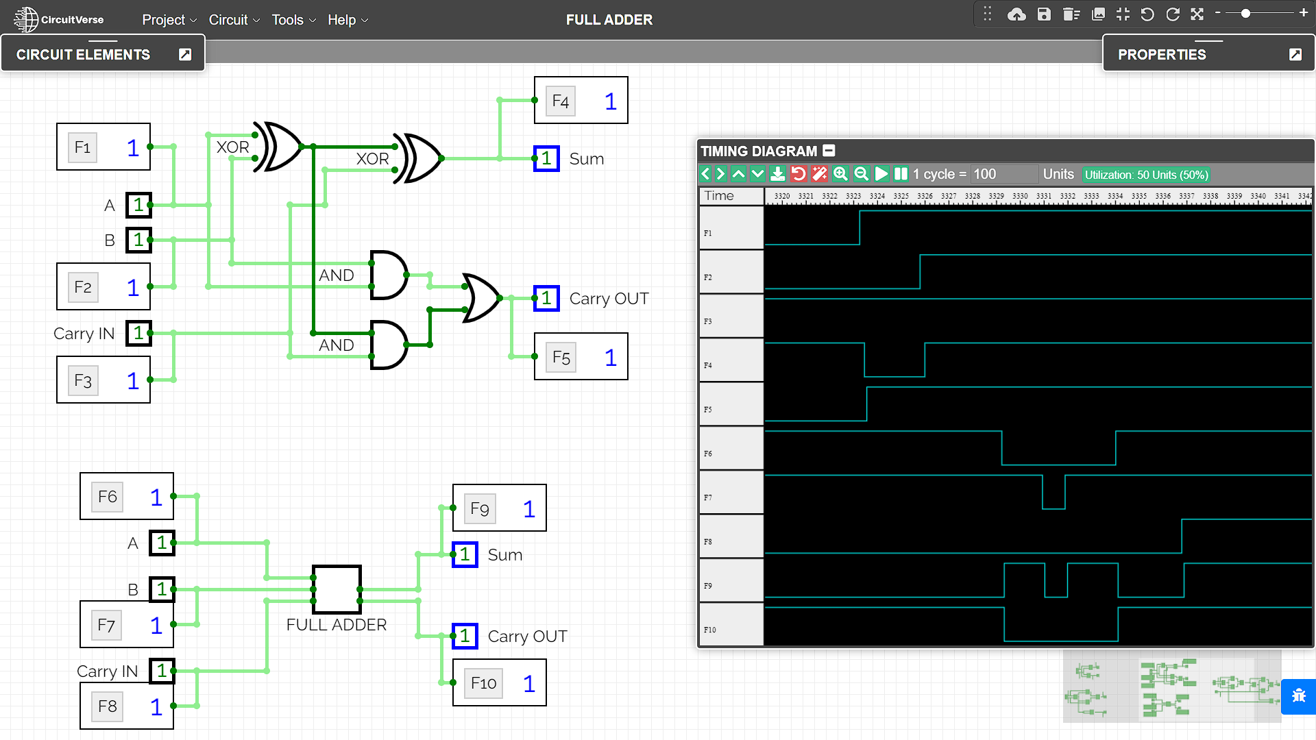

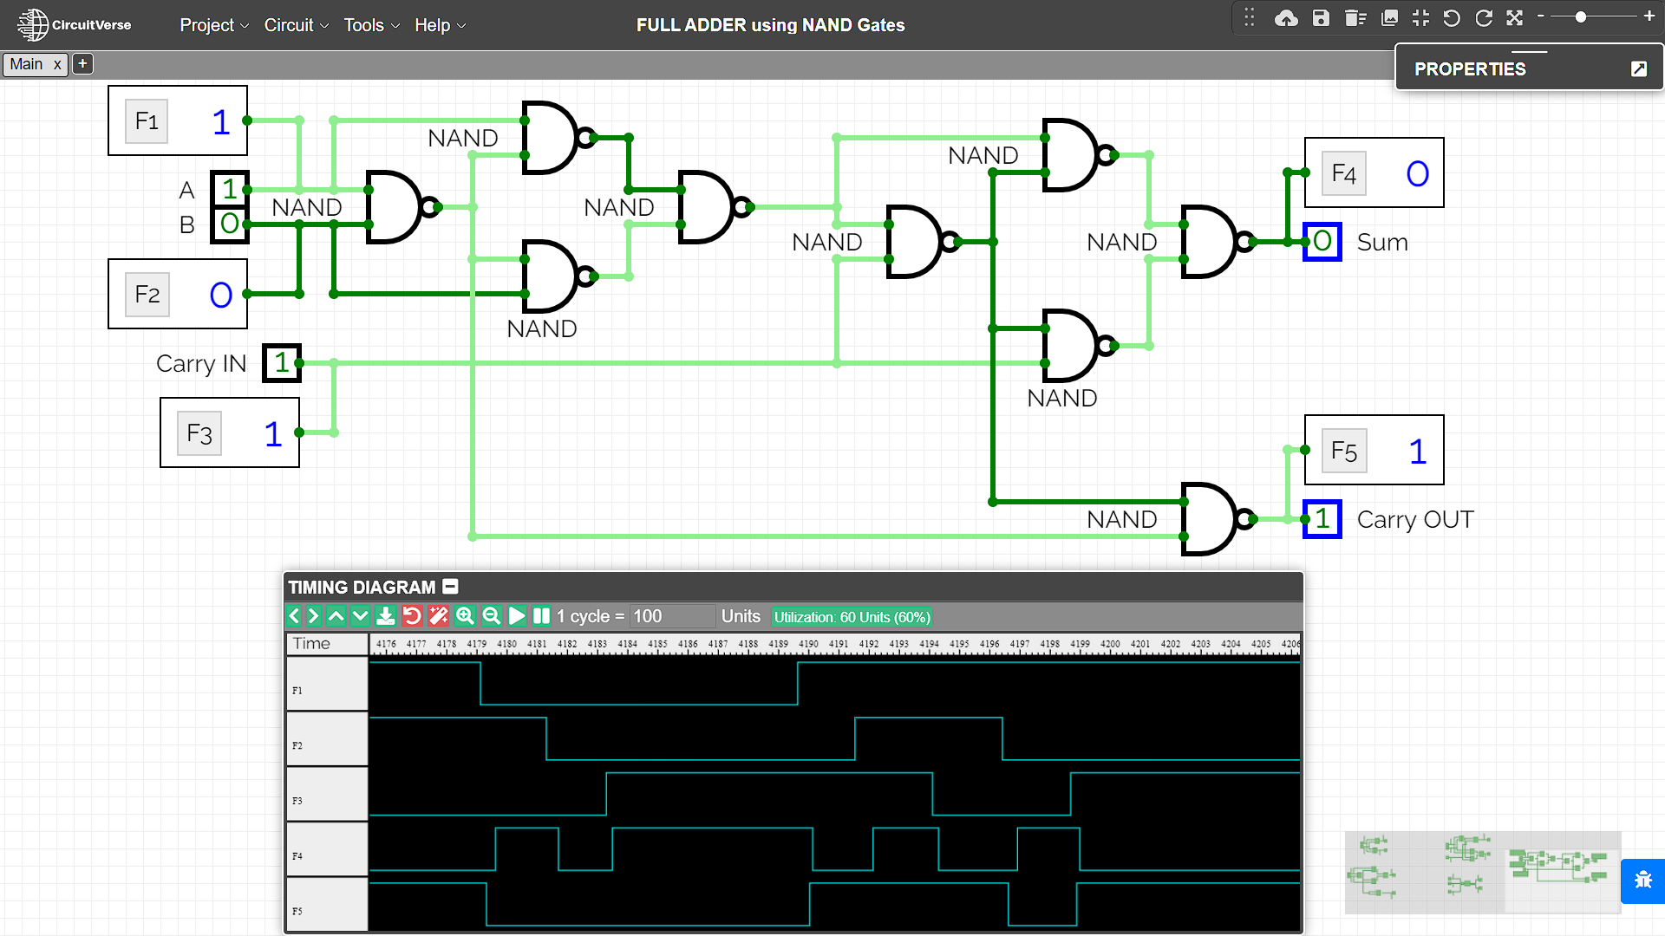

RESULT
The Working of Half adder and Full adder combinational circuit have been analysed and the Truth Tables and Boolean Expressions of half adder and full adder using XOR and NAND gates have been studied and verified using the online simulator.

Criteria | Total Marks | Marks Obtained | Comments
Concept (A) | 2
Implementation (B) | 2
Performance (C) | 2
Total | 6

Experiment – 3a

AIM
To study and design the single bit half subtractor combinational circuit for verifying and interpreting its logic and truth table and for analysing the working of half subtractor circuit by using the ICs of –
  - XOR, NOT and AND gates
  - NAND gates

PLATFORM/TOOL USED
- Simulator: https://circuitverse.org/simulator
- Virtual LAB: https://de-iitr.vlabs.ac.in/exp/half-full-subtractor/

THEORY
Subtractor is an electronic logic circuit for calculating the difference between two binary numbers which provides the difference and borrow as output.
Subtractor circuits take two binary numbers as input and subtract one binary number input from the other binary number input. Like adders, it gives out two outputs, difference and borrow (carry-in the case of Adder). There are two types of subtractors.
- Half Subtractor
- Full Subtractor

Half Subtractor
- The Half Subtractor is a combinational circuit which is used to perform subtraction of two bits.
- It has two inputs, A (minuend) and B (subtrahend) and two outputs Difference and Borrow.
- The logic symbol and truth table are shown below.

Block Diagram for HALF SUBTRACTOR
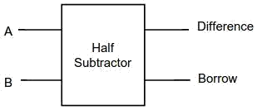

Truth Table for HALF SUBTRACTOR
INPUT |  | OUTPUT
A | B | Difference | Borrow
0 | 0 | 0 | 0
0 | 1 | 1 | 1
1 | 0 | 1 | 0
1 | 1 | 0 | 0

K-Map for HALF SUBTRACTOR
For DIFFERENCE |  |  |  |  | For BORROW
B  A | 0 | 1 |  |  | B  A | 0 | 1
0 | 0 | 1 |  |  | 0 | 0 | 1
1 | 1 | 0 |  |  | 1 | 0 | 0
$$Difference = AB^{'}+A^{'}B$$  $$Difference=A⊕B$$ |  |  |  |  | $$Borrow = \overline{A}B$$
Boolean Expression for HALF SUBTRACTOR
$\boxed{Difference = AB^{'}+ A^{'}B=A⊕B}$ $\boxed{Borrow = \overline{A}B}$

Logic Diagram for HALF SUBTRACTOR
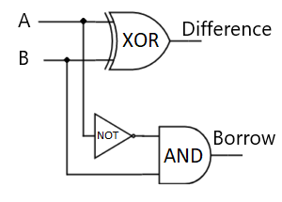

- Five NAND gates are required to design a half subtractor.

Realization of Half Subtractor using 5 NAND gates
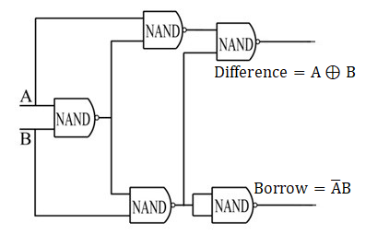
SIMULATED OUTPUT
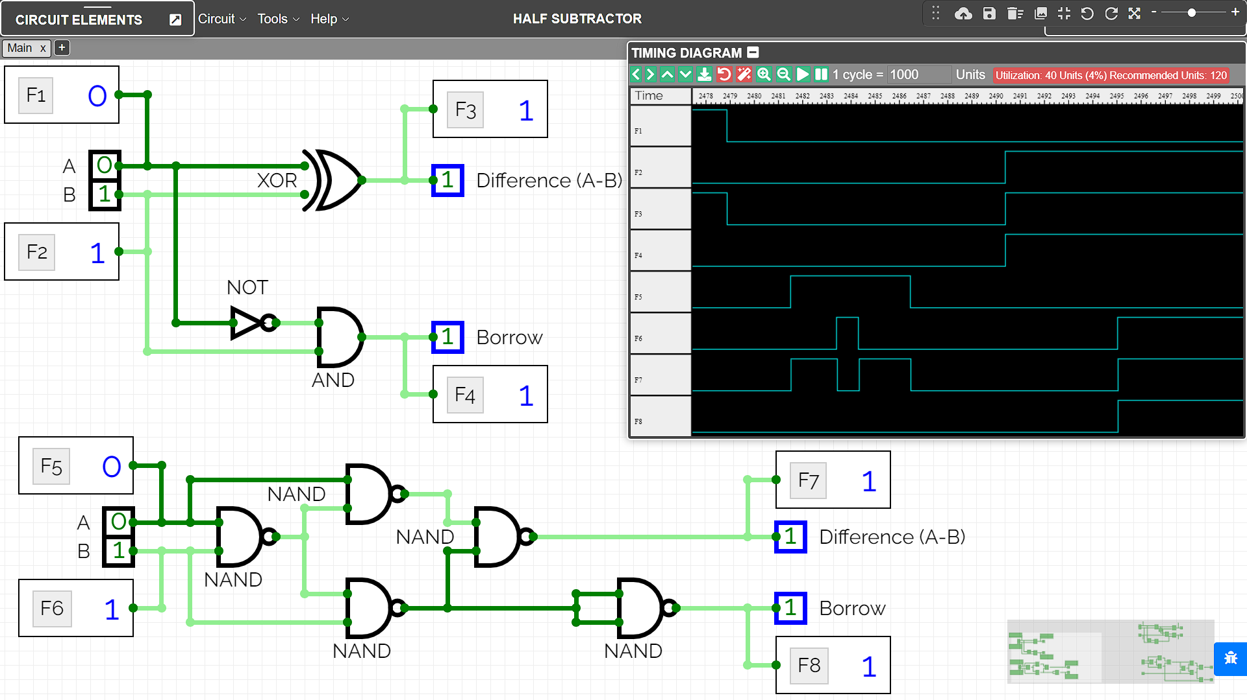

RESULT
The Working of Half Subtractor combinational circuit have been analysed and the Truth Table and Boolean Expression of half subtractor using XOR, NOT & AND gates, and NAND gates have been studied and verified using the online simulator.

Criteria | Total Marks | Marks Obtained | Comments
Concept (A) | 2
Implementation (B) | 2
Performance (C) | 2
Total | 6

Experiment – 3B

AIM
To study and design the single bit full subtractor combinational circuit for verifying and interpreting its logic and truth table and for analysing the working of half subtractor circuit by using the ICs of –
- XOR, AND, NOT and OR gates
- NAND gates

PLATFORM/TOOL USED
- Simulator: https://circuitverse.org/simulator
- Virtual LAB: https://de-iitr.vlabs.ac.in/exp/half-full-subtractor/

THEORY
Subtractor is an electronic logic circuit for calculating the difference between two binary numbers which provides the difference and borrow as output.
Subtractor circuits take two binary numbers as input and subtract one binary number input from the other binary number input. Like adders, it gives out two outputs, difference and borrow (carry-in the case of Adder). There are two types of subtractors.
- Half Subtractor
- Full Subtractor

Full Subtractor
- A Full Subtractor is a combinational circuit that performs subtraction of two bits, one is minuend and other is subtrahend, considering 1 may be borrowed from the previous adjacent lower significant bit.
- It accepts three inputs: A (minuend), B (subtrahend) and a Bin (borrow bit) and it produces two outputs: D (difference) and Bout (borrow out).
- The logic symbol and truth table are shown below.

Block Diagram for FULL SUBTRACTOR
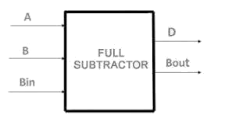

Truth Table for FULL SUBTRACTOR
INPUT |  |  | OUTPUT
A | B | B_{IN} | DIFFERENCE | B_{OUT}
0 | 0 | 0 | 0 | 0
0 | 0 | 1 | 1 | 1
0 | 1 | 0 | 1 | 1
0 | 1 | 1 | 0 | 1
1 | 0 | 0 | 1 | 0
1 | 0 | 1 | 0 | 0
1 | 1 | 0 | 0 | 0
1 | 1 | 1 | 1 | 1
K-Map for FULL SUBTRACTOR
For Difference |  |  |  |  |  | For Borrow_{out}
BC_{IN}  A | 00 | 01 | 11 | 10 |  | BC_{IN}  A | 00 | 01 | 11 | 10
0 | 0 | 1 | 0 | 1 |  | 0 | 0 | 1 | 1 | 1
1 | 1 | 0 | 1 | 0 |  | 1 | 0 | 0 | 1 | 0
$$Difference=A^{'}B^{'}B_{in}+A^{'}BB_{in}^{'}+{AB}^{'}B_{in}^{'}+ABB_{in}$$  $$Difference=A⊕B ⊕B_{IN}$$ |  |  |  |  |  | $$B_{out} = \overline{A}B+\overline{A}B_{in}+BB_{in}$$  $$B_{out}=\overline{A}B+B_{in}\overline{(A⊕B)}$$

Boolean Expression for FULL SUBTRACTOR
$$\boxed{Difference=A^{'}B^{'}B_{in}+A^{'}BB_{in}^{'}+{AB}^{'}B_{in}^{'}+ABB_{in}=A⊕B ⊕B_{IN}}$$
$$\boxed{B_{out} = \overline{A}B+\overline{A}B_{in}+BB_{in}=\overline{A}B+B_{in}\overline{(A⊕B)}}$$

Logic Diagram for FULL SUBTRACTOR
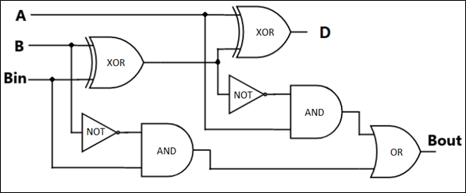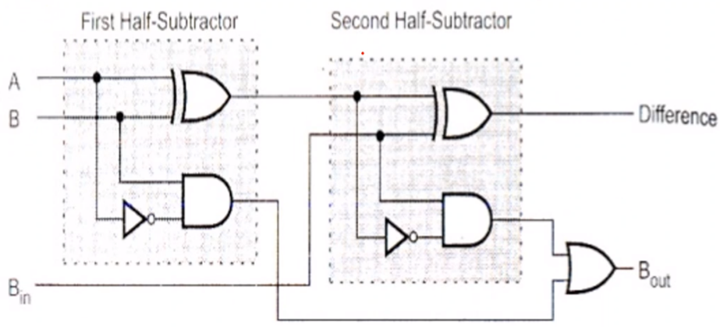

- Nine NAND gates are required to design a full subtractor.

Realization of FULL SUBTRACTOR using 9 NAND gates
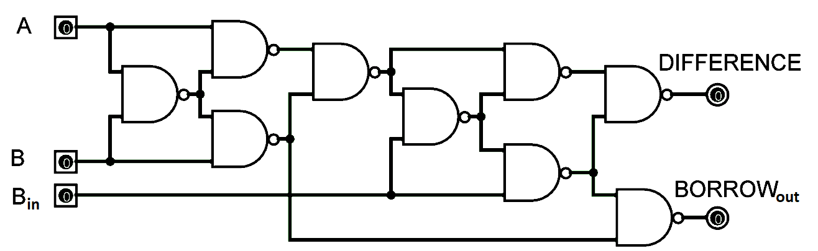

SIMULATED OUTPUT
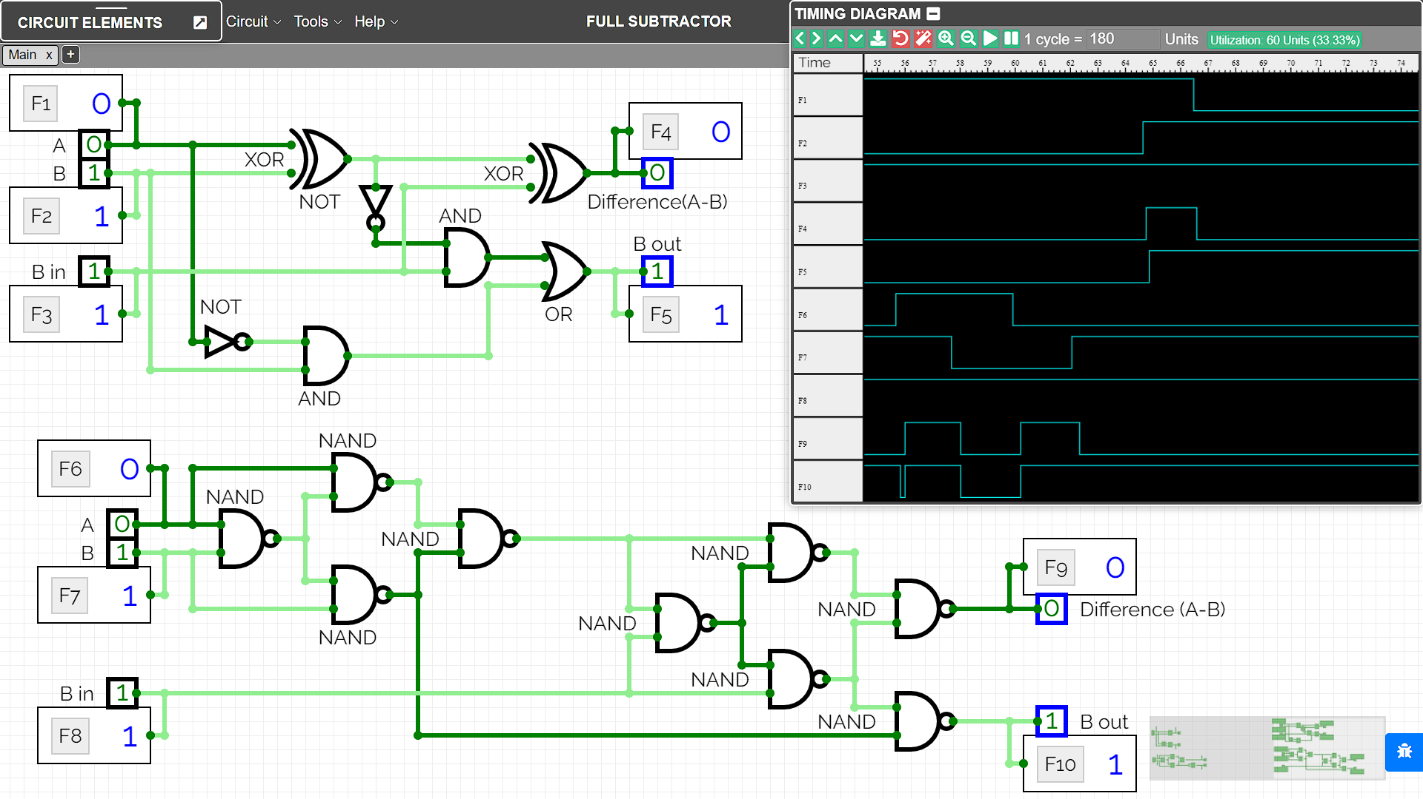

RESULT
The Working of Full Subtractor combinational circuit have been analysed and the Truth Table and Boolean Expression of full subtractor using XOR, NOT,OR & AND gates, and NAND gates have been studied and verified using the online simulator.

Criteria | Total Marks | Marks Obtained | Comments
Concept (A) | 2
Implementation (B) | 2
Performance (C) | 2
Total | 6

Experiment – 4

AIM
To study and design the 4-bit Parallel Adder & Subtractor combinational circuit for verifying and analysing the working of parallel adder subtractor circuit by using the full adders.

PLATFORM/TOOL USED
- Simulator: https://circuitverse.org/simulator

THEORY
Additions and subtractions are fundamental operations in a digital system, control system & digital signal processing. These systems are influenced by the adders and subtractors by providing accurate as well as fast operations. Adders and subtractors play an essential role in digital systems due to their wide usage in other digital operations like multiplication, subtraction & division. Therefore, improving the performance of these will progress the execution of binary operations within a circuit.

Parallel Adder
- A single Full Adder performs the addition of two one-bit numbers and an input carry.
- But a Parallel Adder is a digital circuit capable of finding the arithmetic sum of two binary numbers that is greater than one bit in length by operating on corresponding pairs of bits in parallel.
- It consists of full adders connected in a chain where the output carry from each full adder is connected to the carry input of the next higher order full adder in the chain. A n-bit parallel adder requires n full adders to perform the operation. So, for the two-bit number, two adders are needed while for four-bit number, four adders are needed and so on. Parallel adders normally incorporate carry lookahead logic to ensure that carry propagation between subsequent stages of addition does not limit addition speed.

In modern Integrated Circuits, the most basic and widely used component are Binary Adders. Adder circuit is classified as Half Adder and Full Adder. The Adder circuit is expected to compute fast, occupy less space, and minimize delay. Hence Parallel Adders were implemented with the help of Full Adder circuits.

Logic Diagram for Parallel Adder
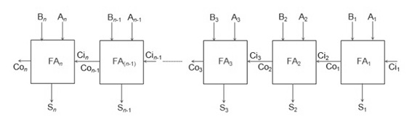

Working of parallel Adder –
- Firstly, the full adder FA₁ adds A₁ and B₁ along with the carry C_{i1} to generate the sum S₁ (the first bit of the output sum) and the carry C_{o1} which is connected to the next adder in chain.
- Next, the full adder FA₂ uses this carry bit C_{i2} to add with the input bits A₂ and B₂ to generate the sum S₂ (the second bit of the output sum) and the carry C_{o2} which is again further connected to the next adder in chain and so on.
- The process continues till the last full adder FA_{n} uses the carry bit C_{n} to add with its input An and Bn to generate the last bit of the output along last carry bit C_{out}.

Parallel Subtractor
A Parallel Subtractor is a digital circuit capable of finding the arithmetic difference of two binary numbers that is greater than one bit in length by operating on corresponding pairs of bits in parallel. The parallel subtractor can be designed in several ways including combination of half and full subtractors, all full subtractors or all full adders with subtrahend complement input.

Logic Diagram for Parallel Subtractor
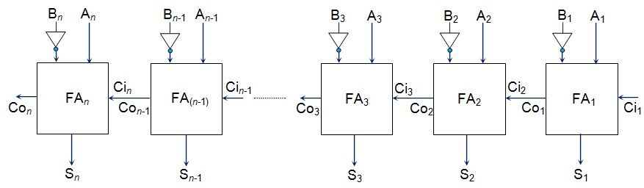

Working of Parallel Subtractor –
- The parallel binary subtractor is formed by combination of all full adders with subtrahend complement input.
- This operation considers that the addition of minuend along with the 2’s complement of the subtrahend is equal to their subtraction.
- Firstly the 1’s complement of B is obtained by the NOT gate and 1 can be added through the carry to find out the 2’s complement of B. This is further added to A to carry out the arithmetic subtraction.
- The process continues till the last full adder FA_{n} uses the carry bit C_{n} to add with its input A_{n} and 2’s complement of B_{n} to generate the last bit of the output along last carry bit C_{out}.

Realization of PARALLEL ADDER SUBRACTOR in a single Combinational Circuit
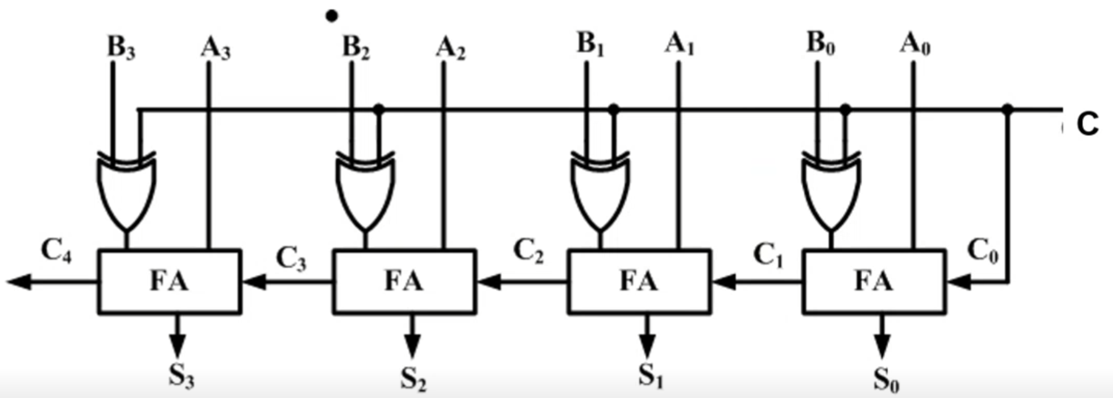

Here, the combinational logic circuit of Parallel Adder Subtractor is shown where there are following modes:
- Set C = 0 for ADDITION
- Set C = 1 for SUBTRACTION

Advantages of parallel Adder/Subtractor –
- The parallel adder/subtractor performs the addition operation faster as compared to serial adder/subtractor.
- Time required for addition does not depend on the number of bits.
- The output is in parallel form i.e., all the bits are added/subtracted at the same time.
- It is less costly.
Disadvantages of Parallel Adder/Subtractor
The major drawback of Parallel Adder/Subtractor is the Propagation Delay. The delay is directly proportional to the length of binary numbers that are to be added.

SIMULATED OUTPUT

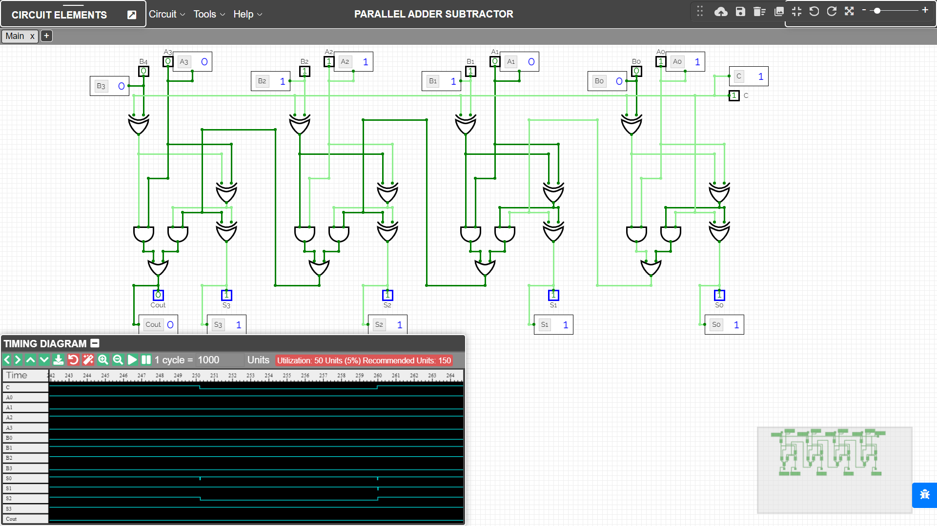

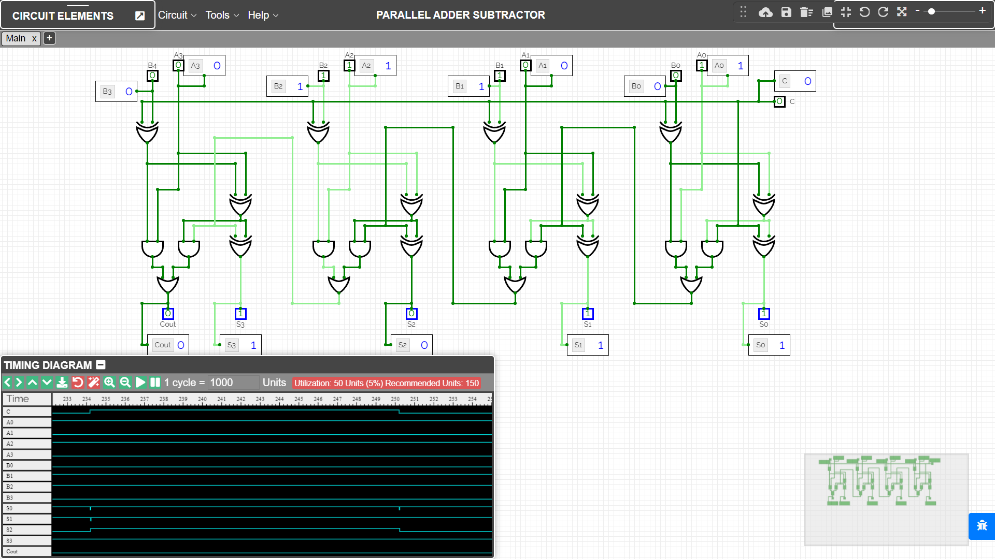

RESULT
The combinational circuits of Parallel Adder & Subtractor have been implemented on the Online Simulator and its working has been studied and analysed using full adders.

Criteria | Total Marks | Marks Obtained | Comments
Concept (A) | 2
Implementation (B) | 2
Performance (C) | 2
Total | 6

Experiment – 5

AIM
To study and design the Logical part Arithmetic Logic Unit ALU using:
- MUX
- Decoder

PLATFORM/TOOL USED
- Simulator: https://circuitverse.org/simulator

THEORY
In Digital electronics, an Arithmetic Logic Unit (ALU) is a combinational digital circuit that performs arithmetic and bitwise operations on binary digital signals.

The ALU is a component which can carry out a range of calculations on its inputs, including various standard arithmetic and logic operations. The choice of operation is made by setting control inputs appropriately; ultimately, the control inputs are determined by the instruction which the CPU is executing at any given time. We'll go further into this idea later in the course.

ALU is also known as an integer unit (IU) that is an integrated circuit within a CPU or GPU, which is the last component to perform calculations in the processor. It can perform all processes related to arithmetic and logic operations such as addition, subtraction, and shifting operations, including Boolean comparisons (XOR, OR, AND, and NOT operations). Also, binary numbers can accomplish mathematical and bitwise operations. The arithmetic logic unit is split into AU (arithmetic unit) and LU (logic unit).
The logic unit can perform the logical operations such as AND, OR, NOT, XOR, NOR, NAND, etc.

The combinational circuit of Logic Unit can be implemented using:

- Multiplexer
- The size of MUX is defined as such where the no. of input lines is same as the no. of logical operations to be performed.
- Each input line will be connected with the respective logic gate for logical operation.
- And the no. of select lines will be evaluated from the no. of input lines using formula $2^{n}$, for instance, no. of inputs = 4, then no. of select lines = n = 2 since 2² = 4.

- Decoder
- The size of decoder will be described with the help of no. of logical operations that is same as $2^{n}$ which will be taken as the no. of output lines.
- Each output line connected with an AND gate that is also joined with the output of logical operation given by the respective logic gate.
- The no. of input lines can be found using formula $2^{n}$, i.e., equal to no. of output lines where n = the no. of input lines.

Truth Table for LOGICAL Operation Selection
$$S_{1}$$ | $$S_{0}$$ | Logical Operation OUTPUT
0 | 0 | AND
0 | 1 | XOR
1 | 0 | NOT
1 | 1 | OR

SIMULATED OUTPUT

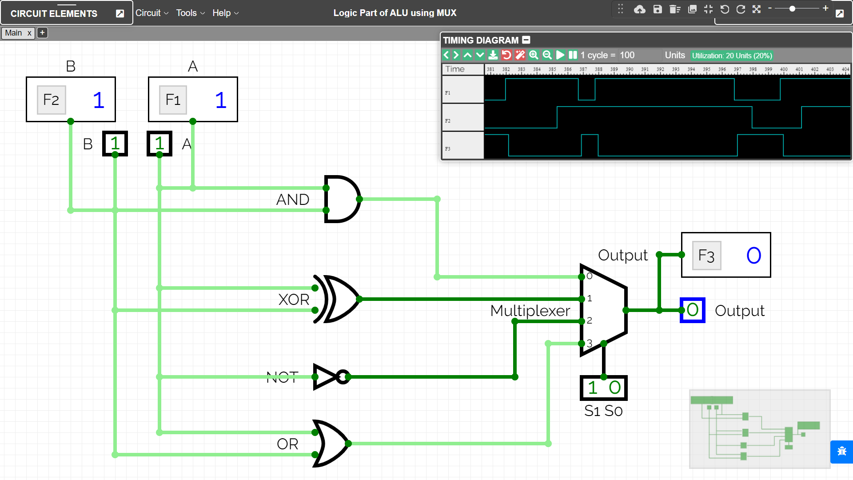

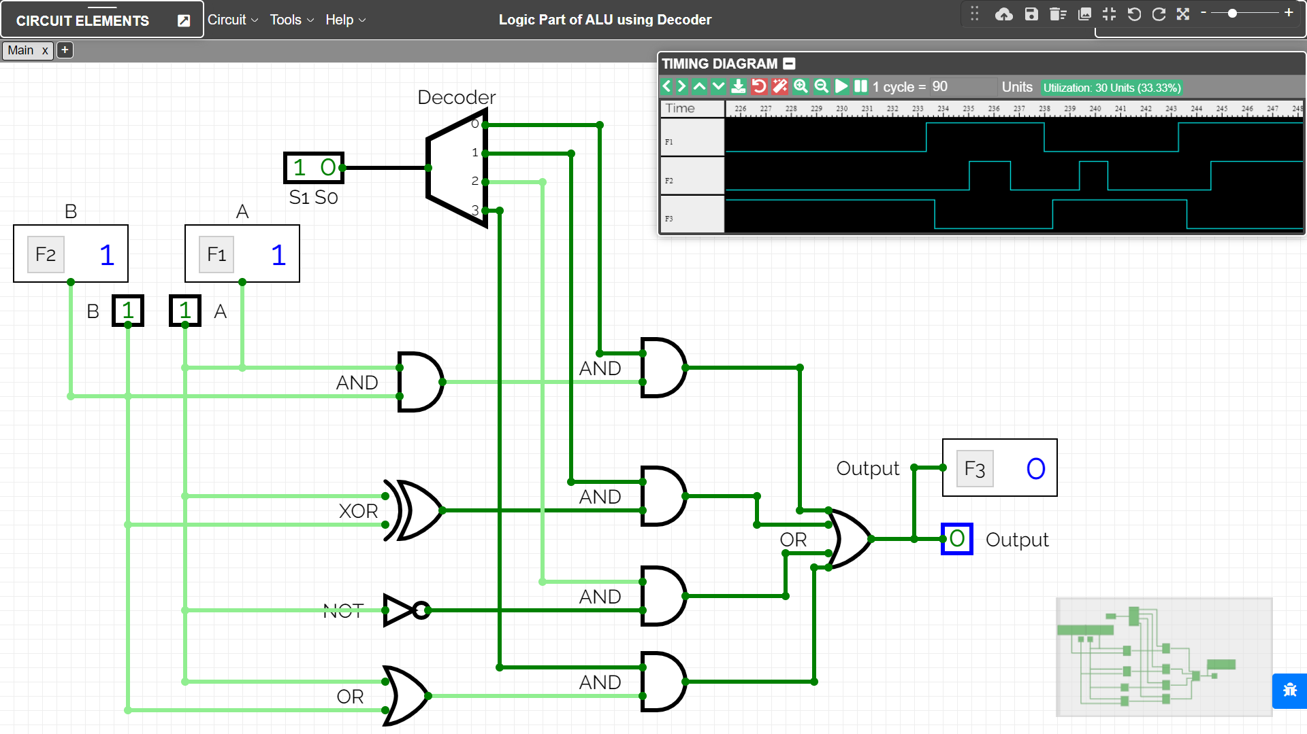

RESULT
The combinational circuits of the Logical Part of ALU using MUX and Decoder have been implemented on the Online Simulator and its working has been studied and analysed.

Criteria | Total Marks | Marks Obtained | Comments
Concept (A) | 2
Implementation (B) | 2
Performance (C) | 2
Total | 6

Experiment – 6

AIM
To design and simulate 5-bit common bus system using multiplexers.

PLATFORM/TOOL USED
- Simulator: https://circuitverse.org/simulator

THEORY
A typical computer has many registers, and the information is transferred between these registers. A way to transfer the information is using the common bus system.

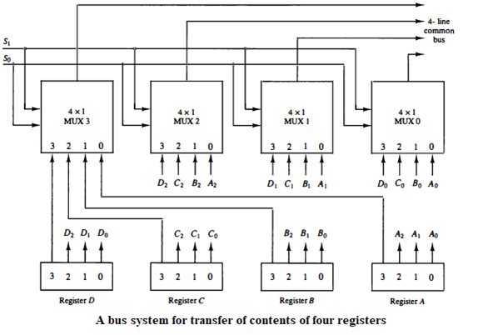

The construction of such bus system for 4 registers is shown above. The bus consists of 4×1 multiplexers with 4 inputs and 1 output and 4 registers with bits numbered 0 to 3. There are 2 select inputs S0 and S1 which are connected to the select inputs of the multiplexers.

The output 1 of register A is connected to input 0 of MUX 1 and similarly other connections are made as shown in the diagram. The data transferred to the bus depends upon the select lines. A table for the various combinations of select lines is shown below.
Truth Table for REGISTER Selection
Select Lines Combination |  |  | Register Selected | MUX line selected in all MUXes | Content transferred on 5-bit Common Bus
S2 | S1 | S0 | Register Selected | MUX line selected in all MUXes | Content transferred on 5-bit Common Bus
0 | 0 | 0 | Register A | 1st input of all MUX | A₄A₃A₂A₁A₀
0 | 0 | 1 | Register B | 2nd input of all MUX | B₄B₃B₂B₁B₀
0 | 1 | 0 | Register C | 3RD input of all MUX | C₄C₃C₂C₁C₀
0 | 1 | 1 | Register D | 4TH input of all MUX | D₄D₃D₂D₁D₀
1 | 0 | 0 | Register E | 5TH input of all MUX | E₄E₃E₂E₁E₀
The transfer of information from some source register to a destination register is performed by transferring the content of the register to the bus and then the contents of the bus to a destination register. This can be accomplished by connecting the bus lines to the inputs of all destination registers and activating the load control of the desired destination register. The symbolic notation for this operation is shown as:
BUS <- C, R1 <- BUS
Or
R1 <- C
The number of multiplexers needed to construct the bus is equal to n, the number of bits in each register. The size of each multiplexer must be $\left(k×1\right)$ since it multiplexes $k$ data lines (or simply the no. of registers)
- No. of MUX = No. of bits in each register
- Size of MUX = No. of data lines it multiplexes (or No. of Registers)

SIMULATED OUTPUT
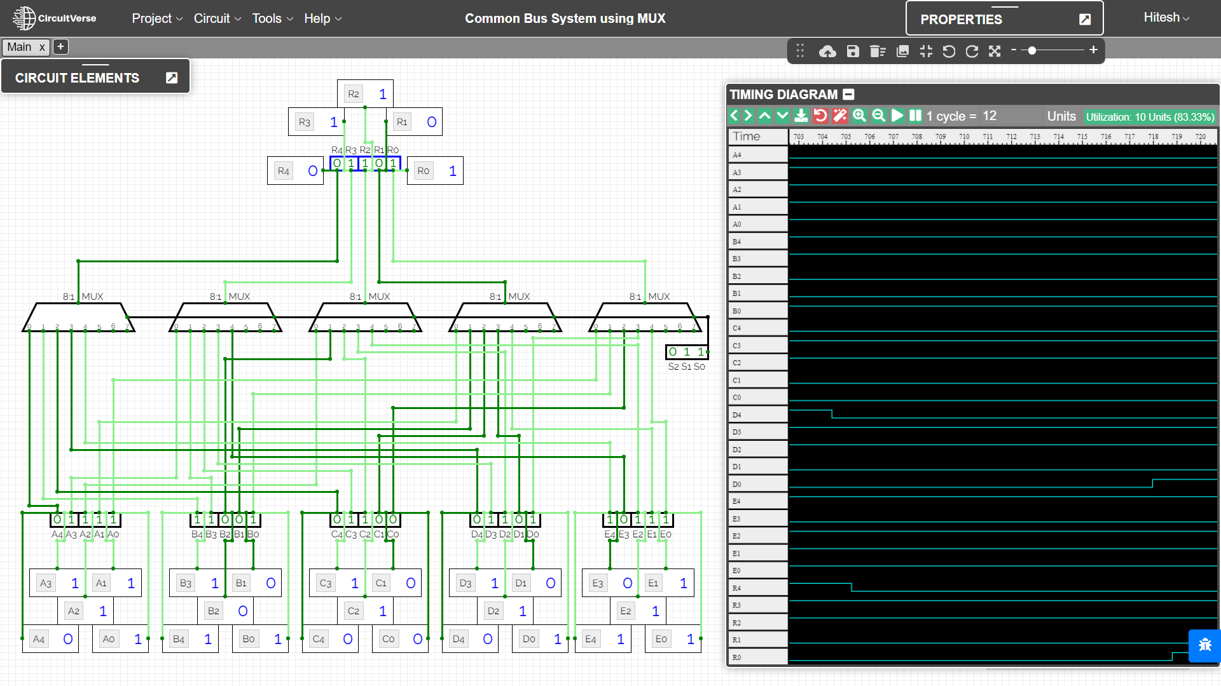

RESULT
The combinational circuit 5-bit common bus system using multiplexers have been implemented on the Online Simulator and its working has been studied and analysed.

Criteria | Total Marks | Marks Obtained | Comments
Concept (A) | 2
Implementation (B) | 2
Performance (C) | 2
Total | 6

